Normal WNT Pathway  
When Off  
Solid curved lines are cellular membrane. Dotted curved lines are nuclear membranes.

The proposed cure is to fill small soapy clusters of molecules, called micelles, to carry drugs into cells and release ICAT into the cells nucleus due to a change in pH in the nucleus [3]. This method is just as effective in cancer cells as well. These micelles will be encased in a capsule of guar gum. A study has shown that guar gum does not degrade until it reaches the colon where bacteria degrade the capsule, allowing for the slow release of the encased drug [4].

Familial Adenomatous Polyposis

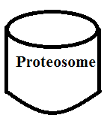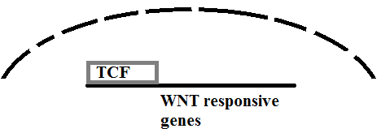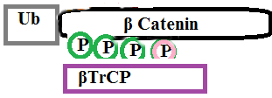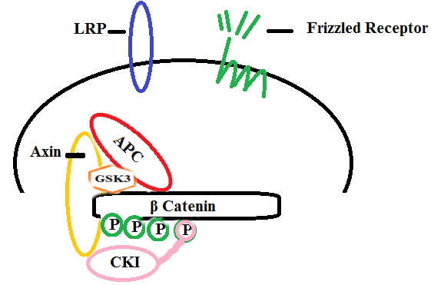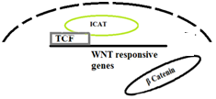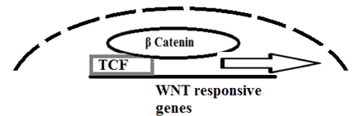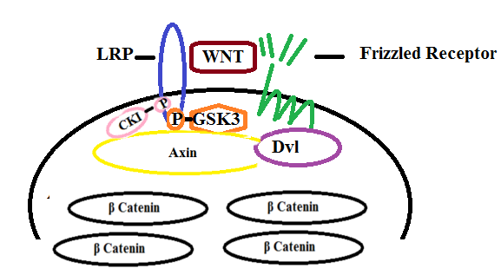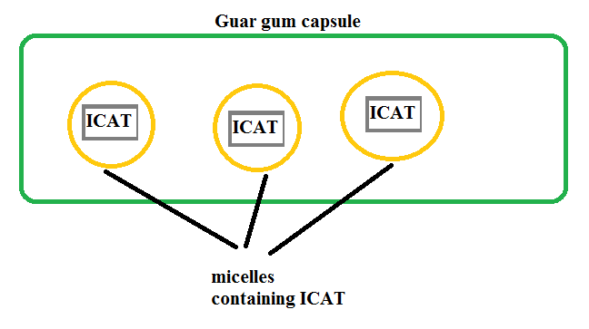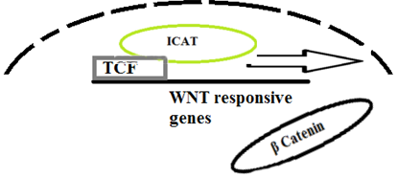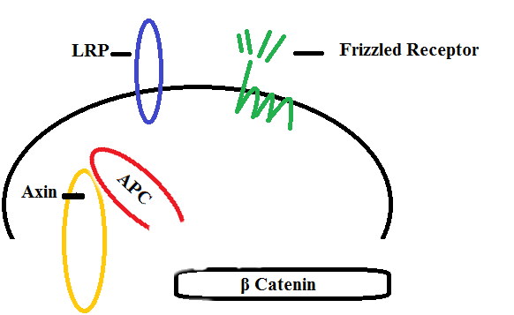

The APC protein becomes too short to form the destruction complex when the WNT pathway is off..

FAP is caused by nonsense or frame shift mutations on chromosome 5.  
Affects epithelial tissue.

β-Catenin moves to the nucleus to bind with TCF, which begins transcribing genes.

iCAT is a "..small protein of 81 amino-acids (encoded by the conserved CTNNBIP1 gene) is known to repress TCF/LEF-β- catenin transcriptional activity in vitro" [2].

Released ICAT bonds with TCF.

Cells will intake micelles.

Guar gum will be broken down by bacteria in the colon.

Micelles break up in the nucleus

Normal WNT Pathway  
When On

The ideal solution would be to block the binding of β-catenin to TCF in the nucleus. β-catenin in the cytoplasm connects cadherin, a protein that connects cells, to the actin cytoskeleton via alpha catenin [1], thus it should be dealt with in the nucleus.

β-Catenin is targeted for destruction by a proteosome and TCF is never activated.

Dr.M. Nedwidek-Moore/Stuyvesant HS Jonathan Quang

Assignment #8/ Due 4/4/16 SBS11QHG Period 10

Opening Declaration: I promise to do this assignment authentically

Student Signature: ________________________ Date:_________

FAP - Familial adenomatous polyposis  
WNT stands for wingless integrated pathway. The pathway involves regulation of gene expression. When off, the related genes are not expressed.  
LRP - Low density lipoprotein receptor-related protein  
APC - Adenomatous polyposis coli  
GSK3 - Glycogen synthase kinase-3  
CKI - Cyclin-Dependent kinase inhibitor  
P - Phosphate group  
Ub - Ubiquitin  
βTrCP - beta-transducin repeat protein  
TCF - Transcription factors  
Dvl - a family of cytoplasmic phosphoproteins called disheveled.   
ICAT - Isotope coded affinity tag that can be used to tag proteins or in this case, block certain protein binding sites.

Works Cited

1. Nisset, J. E., A. R. Redfield, F. Jin, K. A. Knudsen, K. R. Jonhson, and M. J. Wheelock. "Characterization of the Interactions of Alpha- catenin with Alpha-actinin and Beta-catenin/plakoglobin." *National Center for Biotechnology Information*. U.S. National Library of Medicine, 1997. Web. 20 Mar. 2016. <http://www.ncbi.nlm.nih.gov/pubmed/9152027>.

2. Domingue, Melanies J., Florian Rambow, Bastien Job, Laura Popon, Wanguo Liu, Lionel Larue, and Jacky Bonaventure. "ICAT, Inhibitor of β- catenin and TCF4, a New Modulator of Melanoma Cells Motility and Invasiveness." *Cancer Research*. Journal of Cancer Research, 10 Feb. 2014. Web. 03 Apr. 2016. <http://cancerres.aacrjournals.org/content/early/2014/02/08/0008-5472.CAN-13- 0920.full.pdf+html>.

3. Schultz, Nora. "Nanocarriers Come Through." *MIT Technology Review*. MIT Technology Review, 6 Jan. 2011. Web. 03 Apr. 2016. <https://www.technologyreview.com/s/422297/nanocarriers-come-through/>.

4. Rajpurohit, H., P. Sharma, S. Sharma, and A. Bhandari. "Polymers for Colon Targeted Drug Delivery." *Indian Journal of Pharmaceutical Sciences*. Medknow Publications, Nov.-Dec. 2010. Web. 03 Apr. 2016. <http://www.ncbi.nlm.nih.gov/pmc/articles/PMC3178968/>.

Closing Declaration: At the close of this assignment, I can attest to having done it by my own hand. If I received help from peers or from tutors in doing it, this was purely to understand the material, and I did not knowingly transfer the information from or to other sources (my peers or otherwise) in the process of doing this work

Student Signature: ________________________ Date:_________